# Project management links

## Github:

Github available at: <https://github.com/HarrisonWent/EscapeRoom>

For this project we decided on using Trello for managing our tasks which we discussed at our weekly meetings.

## Trello (Programmer board)

Invite link:

<https://trello.com/invite/b/xk8RZtGJ/be81ca8fa6f6a9ce9096ea8cf15fc16c/programmers>

Board link:

<https://trello.com/b/xk8RZtGJ/programmers>

## Trello (Deisgner board)

Invite link:

<https://trello.com/invite/b/ub4rGJG0/19e06f18210254d8a6db097306172114/designers>

Board link:

<https://trello.com/b/ub4rGJG0/designers>

## Programmer board:

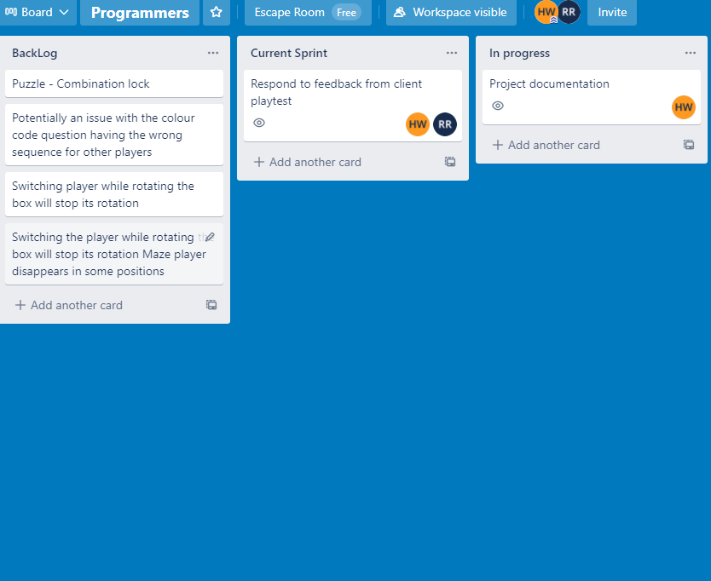

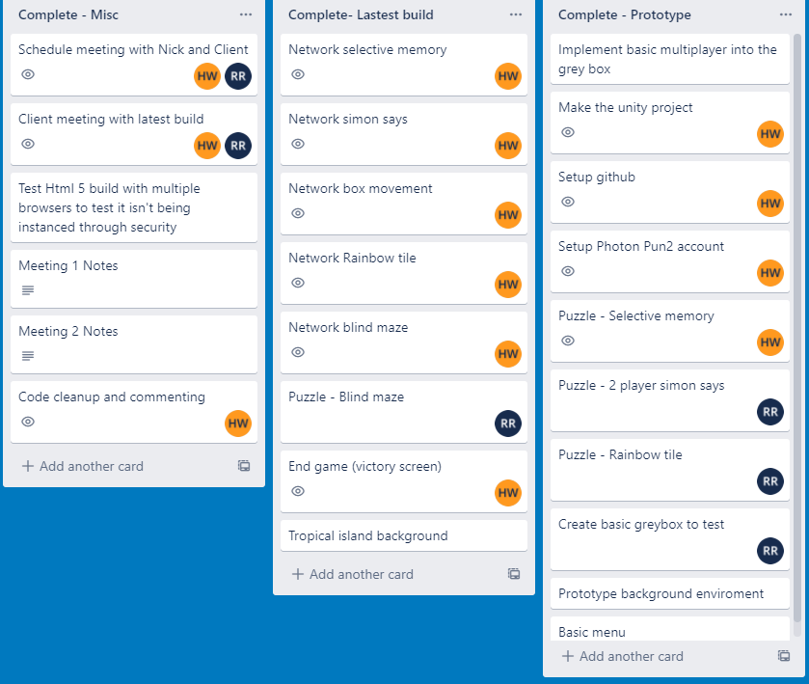

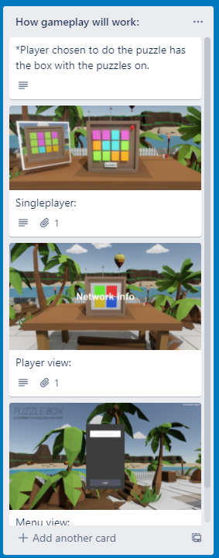

## Designer board:

